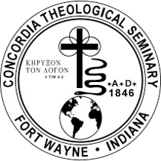
Concordia Theological Seminary Food and Clothing Co-op, Fort Wayne for Seminary Students

$2,000
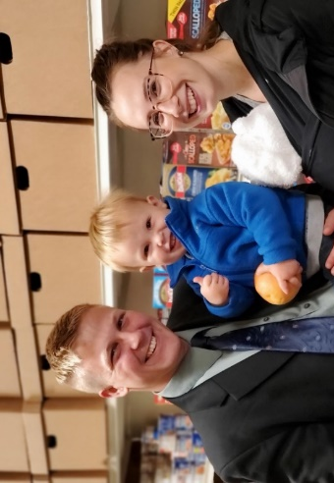
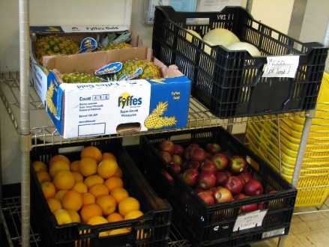
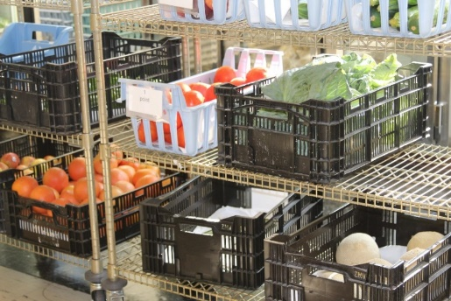

The Food and Clothing Co-op on the campus of Concordia Theological Seminary plays a key role in helping students feed and clothe their families during their seminary years. Nearly 60 percent of the students are married. When the decision is made to leave their jobs and come to the seminary, the students no longer have the same financial flow of funds that they had before but continue to have the same financial needs.

One of the ways that the seminary seeks to reduce this financial burden is by providing access to a Food and Clothing Co-op. The Co-op is supported through the donations of individual donors, churches, and other organizations and is currently able to supply between 80% and 85% of all food and household needs each month at no cost to the student.

This grant from the LWML Washington-Alaska District is important to the seminary and very much appreciated.

2022-2024 Biennium – LWML Washington-Alaska District

